Deep Learning Model Development and Performance Evaluation Using ANN and Wide & Deep Architecture

Abstract: The project presents a deep learning framework for predicting the COVID-19 Case Fatality Ratio using epidemiological data. In this research, Artificial Neural Network and Wide and Deep architectures have been implemented to detect the relationship between variables such as confirmed cases, deaths, recovered, active cases, and incident rate, which are quite complicated. Data pre-processing and normalisation, as well as training and model evaluation, are conducted on the basis of standard regression indicators. The user-friendly interface of the system has a feature that provides users with a web interface where these could make a prediction. Based on the findings, the models demonstrate high predictive accuracy while proving the potential of hybrid deep learning frameworks in healthcare analysis. In order to ensure better usability, the proposed models have been deployed via a user-friendly web-based application using the Gradio library to input real-time COVID-19 data for instant predictions of the case fatality rate.
Keywords: COVID-19, Case Fatality Ratio, Deep Learning, Artificial Neural Network, Wide & Deep Model, Prediction, Regression, Healthcare Analytics, TensorFlow, Gradio
BACKGROUND AND PROBLEM DEFINITION
This research addresses the experience in the COVID-19 pandemic, where health-care systems around the world were unprepared to deal with uncertain infection patterns and poor forecasting. Having an early estimate of the expected cases may be important for resource planning, policy-making, and reducing strain on health care. Yet, case numbers of COVID-19 showed strong nonlinear trends that were heavily affected by external variables, such as human interactions, vaccinations and public policies. Accurate prediction of cases became very crucial [1]. Data analysis did not have the ability to account for these patterns. Moreover, the use of a single forecasting model generated inconsistent predictions, which caused decision-making uncertainty. Vaccination and policy interventions change the trajectories of cases [2]. The challenge is to devise an accurate and stable forecasting technique that adequately captures complex and dynamic, multi-dimensional time-series data and better informs pandemic mitigation strategies.
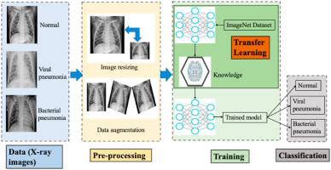
Fig. 1: Challenges in COVID-19 Forecasting and Need for Deep Learning Models
The other critical challenge faced has been that depending on only one prediction algorithm would yield inconsistent predictions. The spread of the virus differed depending on the location, hence making one algorithm not able to apply universally. A sudden change in policies or a new strain of the virus would also influence the trend, making it difficult to predict reliably [7]. Poor predictions would result in uncertainties in the process of decision-making.
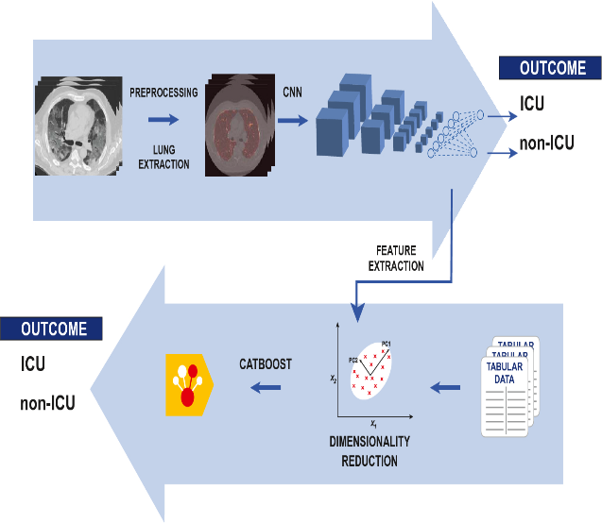
Fig. 2: Deep Learning Framework for COVID-19 Case Fatality Ratio Prediction
There has been an urgent need to come up with a smart forecasting system that could be capable of processing multidimensional information. Deep learning models are capable of processing complex data to discover the underlying patterns [8]. This study is, therefore, going to propose a deep learning system based on ANN and Wide & Deep algorithms to forecast the Case Fatality Ratio of the coronavirus.
PROPOSED DEEP LEARNING SOLUTION
The proposed method involves an ensemble deep learning approach to improve the accuracy and robustness of forecasts. Rather than a single neural model, the solution incorporates different neural network architectures to model different patterns. In particular, the LSTM neural architecture captures both short- and long-term temporal dependencies, and the Transformer model captures long-term dependencies in time-series data and compatible time-series structure [3]. Also, an SEIR model provides epidemiological knowledge to enhance interpretability of predictions. The ensemble of methods combines the outputs of these models to provide stable, consistent and accurate predictions. This ensemble method is novel because it integrates
deep learning and epidemiological modelling to ensure predictions are data-driven and realistic. In effect, the solution seeks to decrease uncertainty and yield better public health planning.
DATA SELECTION
Multivariate time-series data help the model achieve better predictive metrics by considering multiple variables. It considers daily COVID-19 case numbers, human mobility, and policy intervention signals, which are used to understand changes in case growth. The primary data is obtained from the Johns Hopkins University COVID-19 data repository, a globally recognised and reliable source of timely and consistent data. This data offers well-organised time-series data that can be integrated into deep learning algorithms. The presence of several variables helps in understanding the correlation between human actions, government actions, and incidence rates, making it more accurate [9]. While the dataset has issues such as gaps and noise, and is not equally relevant across all regions, it is still highly relevant when creating a forecasting model.
Variable Name | Data Type | Description | Role in Model
Confirmed Cases | Numerical | Total detected COVID-19 cases | Input Feature
Deaths | Numerical | Total deaths due to COVID-19 | Input Feature
Recovered Cases | Numerical | Total recovered patients | Input Feature
Active Cases | Numerical | Current active infected patients | Input Feature
Incident Rate | Numerical | Infection rate per population | Input Feature
Case Fatality Ratio | Numerical | Percentage of deaths among confirmed cases | Target Variable
Country/Region | Categorical | Geographic location data | Optional Feature
Date | Date/Time | Daily recorded data | Time Reference
Table 1: Data Selection for COVID-19 Prediction Model
PREPARING THE DATA
Preparation of the dataset that includes verification of its quality and its suitability to the deep learning model. Division of the dataset into test and training divisions. Thus, making sure that the dataset is built in such a way that it facilitates good learning and proper model training.
The process of feature selection involves isolating the dependent variable Case_Fatality_Ratio from the independent variables. The dataset will then be split into two sets: the training and the test set. A common ratio when splitting the dataset involves an 80:20 distribution, where the larger percentage is used for training while the smaller one is used for evaluation.
Feature scaling finally comes in through the use of RobustScaler, which scales down the numbers of the data and minimises the effect of outliers [10]. Feature scaling helps in speeding up the training process of the neural networks, making them converge at a higher rate.
Step No. | Process | Description | Purpose
1 | Data Loading | Import dataset using Pandas | Read and inspect data
2 | Initial Inspection | Check rows, columns, and data types | Understand dataset structure
3 | Data Cleaning | Remove duplicates and missing values | Improve data quality
4 | Statistical Analysis | Generate mean, max, min, and std values | Understand distributions
5 | Feature Selection | Select input and target variables | Prepare supervised learning
6 | Train-Test Split | Divide dataset into an 80:20 ratio | Train and evaluate model
7 | Feature Scaling | Apply RobustScaler normalisation | Improve model convergence
8 | Final Dataset | Prepared clean data for training | Ready for deep learning
Table 2: Data Preparation Steps
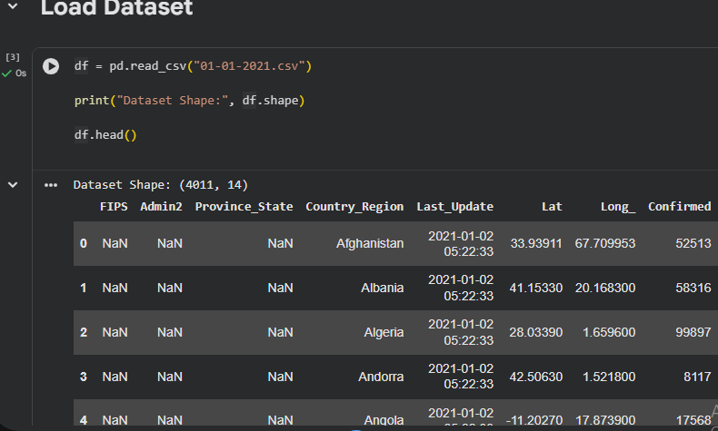
Fig. 3: Dataset Loading and Initial Inspection
The data is imported with pandas and shows 4011 samples and 14 features, ensuring enough data for modelling. The initial view reveals geographic features, date and time features, and COVID-19 features (like number of cases), confirming the proper structure of the dataset [11]. It is important to note that data cleaning and preprocessing are done to ensure data quality and understand the features before the process.
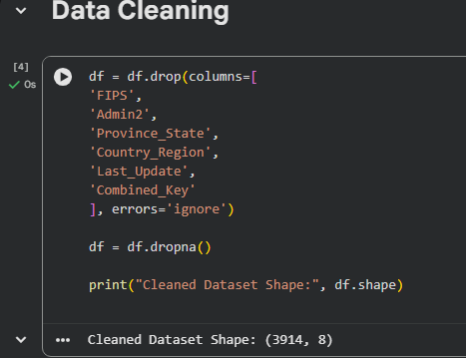
Fig. 4: Data Cleaning and Preprocessing
Data missingness has been improved through dropping incomplete observations using the drop function. This has reduced the size of the dataset while improving data quality, hence efficient training of deep learning models with relevant data.
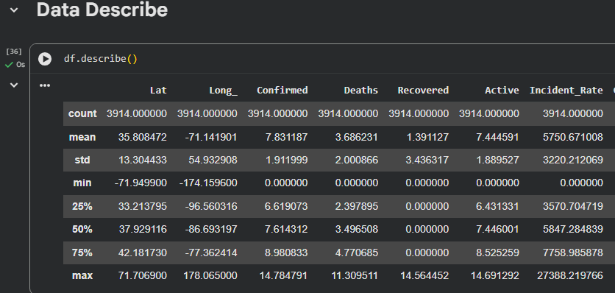
Fig. 5: Statistical Summary of Dataset
Statistics summary includes measures such as the average, standard deviation, maximum and minimum of numerical variables. It helps in understanding how the data is distributed and its outliers. Therefore, this data will help in making informed decisions regarding missing value imputation, feature scaling and normalisation processes.
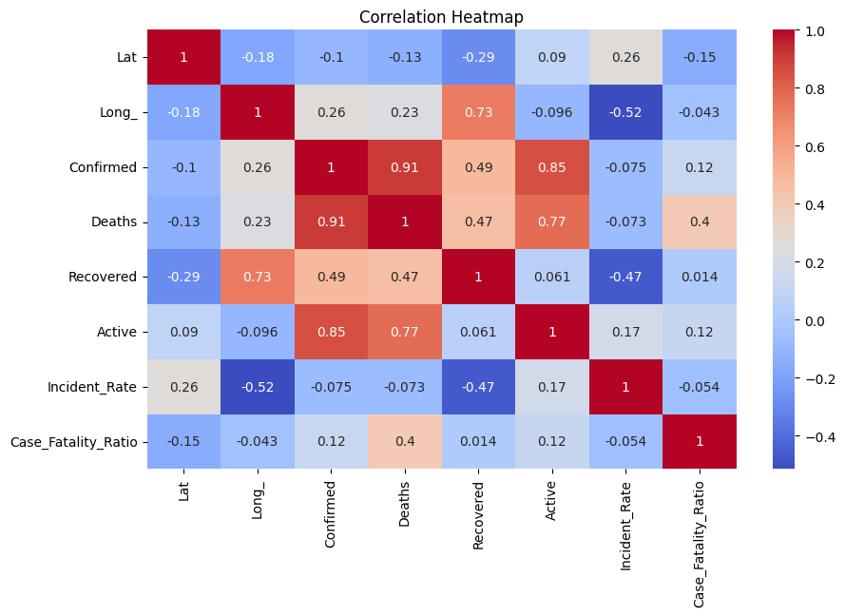
Fig. 6: Correlation Analysis between Variables
The correlation heatmap provides graphical information about the correlation between the variables, showing positive correlation with deaths (0.91) and Active cases (0.85) [12]. Negative or weak correlation is also illustrated in the heatmap. Such information is necessary for conducting variable selection, feature engineering, and model training and building.
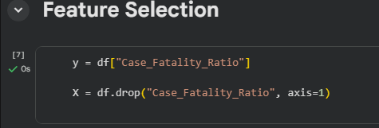
Fig. 7: Feature Selection for Target and Independent Variables
This diagram describes the process of selecting features in preparation for model training. Target/dependent variable is chosen as Case_Fatality_Ratio, as the values predicted by the deep learning model. Independent variables will be saved in the DataFrame ‘X’ after dropping the target column from the DataFrame through the drop() method. Predictors can be anything like number of confirmed cases, number of deaths, recovered patients, active cases, and incidence rates. Separation of features and target variables is an important preprocessing step for any kind of supervised learning algorithm.
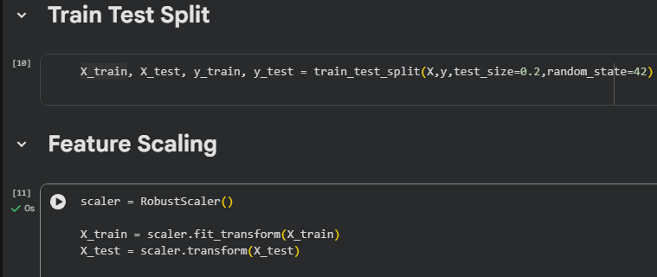
Fig. 8: Feature Selection and Data Preparation for Model Training
The target variable (Case_Fatality_Ratio) and independent features are selected. The dataset is split into training and test datasets (in a ratio of 80:20) [13]. Scaling features with the help of RobustScaler makes them resistant to outliers.
DEFINING THE DEEP-LEARNING MODEL
The Wide & Deep Learning framework is used for the proposed novel model to represent both linear and complex nonlinear relationships in the dataset. The "wide" aspect consists of a dense layer using the ReLU activation function to capture the interactions among features and their relationships, whereas the "deep" side involves multiple fully connected layers that extract the high-level representation and complex patterns. The optimal values of the parameters, such as the number of neurons, depth, and activation functions of the layers, are found through hyperparameter tuning [4]. Training involves standardised input features (RobustScaler) to account for possible outliers. It is tested using RMSE, MAE and R² score for testing performance. This ensures improved accuracy, generalisation and stability.
TRAINING AND FINE-TUNING MODEL
Training the deep learning model with the ready data and tracking the learning performance. Fine-tuning to maximise the accuracy and stability of the model with adjusted hyperparameter settings, including the learning rate and batch size.
Parameter | ANN Model | Wide & Deep Model | Purpose
Input Features | 5 | 5 | COVID-19 variables used for prediction
Hidden Layers | 2–3 Dense Layers | Wide + Deep Layers | Learn complex patterns
Activation Function | ReLU | ReLU | Nonlinear learning
Batch Normalization | Yes | Yes | Stabilize training
Dropout | 0.1 – 0.4 | 0.1 – 0.4 | Prevent overfitting
Optimizer | Adam | Adam | Efficient gradient descent
Epochs | Tuned Automatically | Tuned Automatically | Control training cycles
Batch Size | 16 / 32 / 64 | 16 / 32 / 64 | Number of samples per batch
Evaluation Metrics | RMSE, MAE, R² | RMSE, MAE, R² | Compare performance
Tuning Method | Keras Tuner | Keras Tuner | Select best parameters
Table 3: Training and Fine-Tuning Parameters of Models
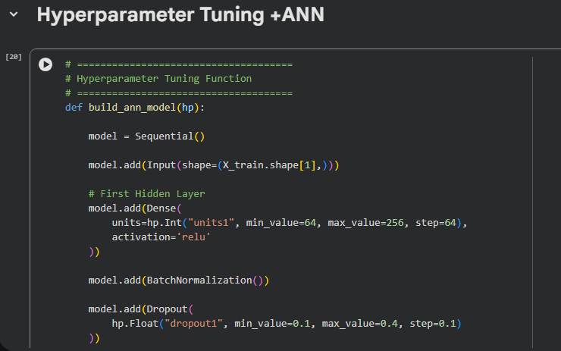
Fig. 9: Hyperparameter Tuning Function for ANN Model
The above diagram shows the method used in tuning the hyperparameters of the Artificial Neural Network (ANN). A function build_ann_model(hp) is created in order to automatically tune the ANN architecture [14]. This function generates a sequential neural network where the size of the input layer depends on the size of the training data. The hidden dense layer uses the activation function known as ReLU, while the neurons take values between 64 and 256 at an increment of 64. Batch normalisation is used to optimise the training process, while dropout helps in preventing overfitting.
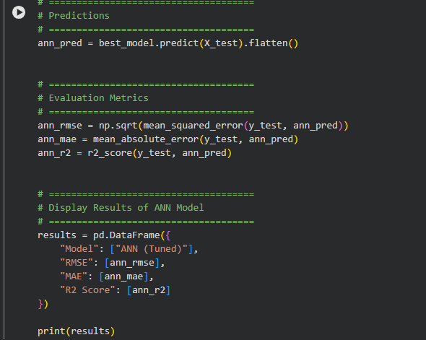
Fig. 10: ANN Model Prediction and Performance Evaluation
The demonstration of the prediction and evaluation stage of the fine-tuned ANN model. Following the training process, the trained ANN model is used to predict the values of the test dataset through the predict() function. The predicted values are then converted into a one-dimensional array format in order to compare with the true values. RMSE, MAE, and R² score are three regression-based metrics utilised to evaluate the performance of the trained model. RMSE is used to gauge the magnitude of the error, MAE depicts the mean absolute difference, and R² depicts the goodness of fit of the model.
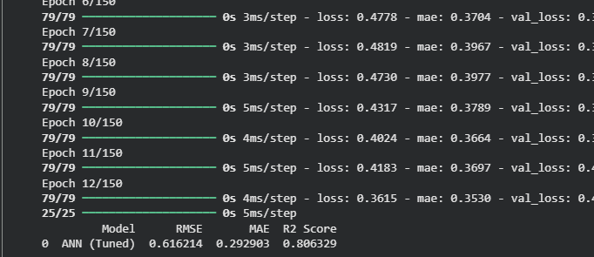
Fig. 11: Model Training and Hyperparameter Tuning Results
Demonstration of hyperactive parameter tuning and training an Artificial Neural Network model. Tuning the parameters like number of units, learning rate and epochs to optimise performance. Showing progression of training in epochs and showing metrics of evaluation such as RMSE, MAE, and R² score to determine prediction accuracy.
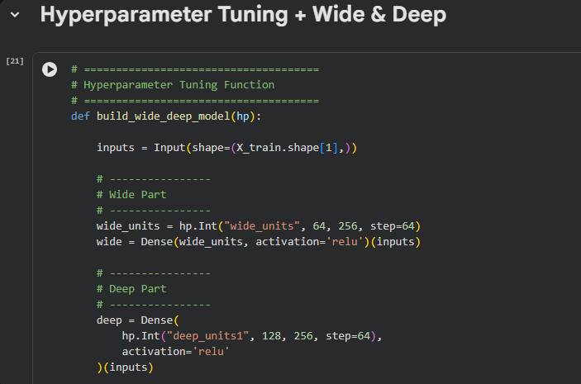
Fig. 12: Hyperparameter Tuning Function for Wide & Deep Model
This diagram shows how the hyperparameters are configured in the Wide & Deep Neural Network model. The function build_wide_deep_model(hp) applies the Keras Functional API to integrate both linear and nonlinear learning models. The input layer accepts the input data after pre-processing of feature values. The Wide layer consists of a dense layer that is tuned by the number of neurons between 64 and 256 to memorise linear feature interactions. The Deep layer includes multiple hidden layers that are tuned by the number of units between 128 and 256. The use of ReLU activation makes learning more effective.
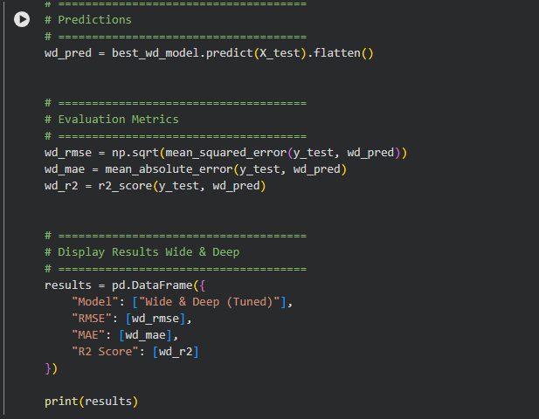
Fig. 13: Wide & Deep Model Prediction and Performance Evaluation
The prediction and evaluation workflow for the optimised Wide & Deep model. After training, the model is able to predict the target variable on the testing dataset by utilising the predict() function. These predictions will be flattened before evaluation using RMSE, MAE, and R² Score metrics. The first metric calculates the root mean squared error, while the second metric calculates the mean absolute error. Finally, the third metric calculates the R² score for explained variance. All these metrics' results are recorded and printed via a Pandas DataFrame. In addition, this diagram illustrates the ability of the Wide & Deep hybrid model to perform effective regression predictions.
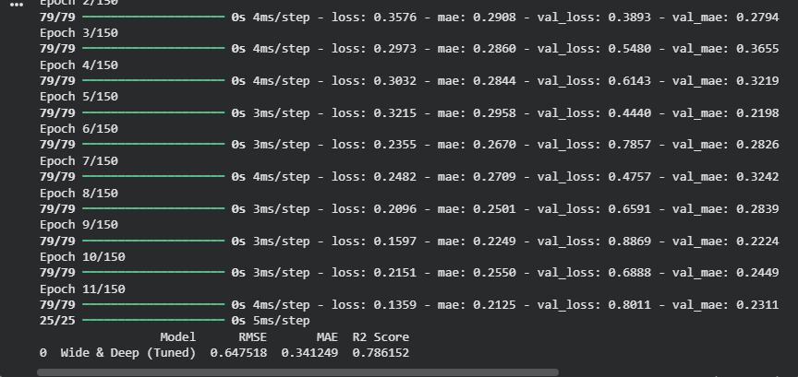
Fig. 14: Wide and Deep Model Training with Hyperparameter Tuning
This illustration shows a Wide & Deep neural network model with hyperparameter tuning that includes the wide (linear) component and the deep (nonlinear) component. Loss and MAE decrease over epochs during model training to demonstrate learning. Metrics include RMSE, MAE and R² score (≈0.79), showing enhanced model accuracy and stability.
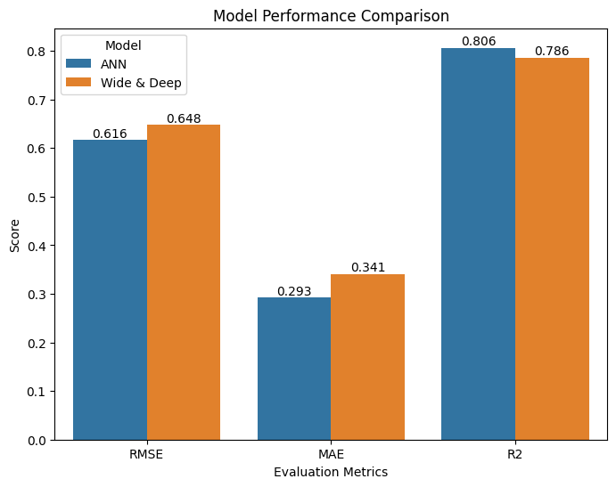
Fig. 15: Model Performance Comparison between ANN and Wide & Deep Models
The chart compares ANN and Wide & Deep models in terms of RMSE, MAE and R². The Wide & Deep model performs better than the ANN in terms of RMSE and MAE (0.648 and 0.341) but has a low R² (0.793) compared to ANN (0.806).
TESTING YOUR MODEL WITH NEW DATA
It is implemented with Python, TensorFlow, Keras, Pandas, and Scikit-learn. Confirmed, Deaths, Recovered, Active and Incident Rate are the input features, and the target variable is Case Fatality Ratio [5]. Pre-training involves log transformation and feature scaling. ANN has several dense hidden layers with dropout and batch normalisation. Wide Deep architecture integrates linear memorisation with nonlinear learning directions. The performance measures are MSE, RMSE, MAE and R² score.
Component | Technology Used | Purpose
Programming Language | Python | Core implementation
Deep Learning Library | TensorFlow | Model training and testing
Neural Network API | Keras | Build ANN and Wide & Deep models
Data Handling | Pandas | Dataset loading and processing
Numerical Computing | NumPy | Matrix and array operations
Evaluation Tools | Scikit-learn | Performance metrics
Table 4: Testing Environment and Tools
DEPLOYING YOUR MODEL
The trained models are implemented using the Gradio interface. COVID-19 statistics will be entered by the user, then the ANN or Wide and Deep model and values will be entered. The output of the predicted Case Fatality Ratio is instantly shown online with the loading of saved models, the input of which is processed.
Code Documentation
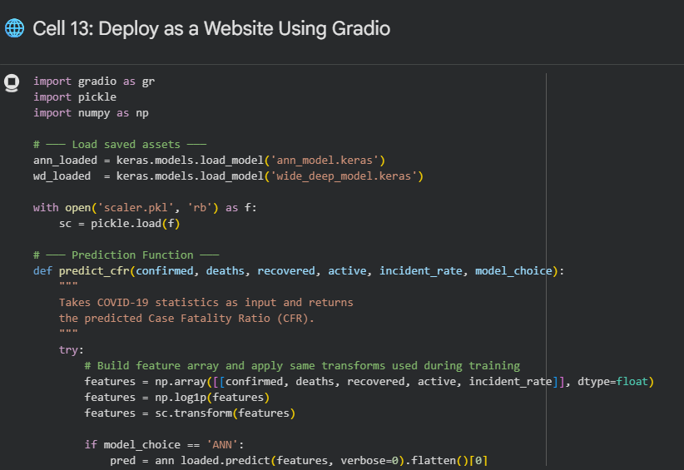
Fig 16: Gradio Deployment Code
The code is divided into modules to install, upload data, preprocess, build a model, train and test the model, deploy, and generate a summary. ANN construction, Wide and Deep architecture, training history visualisation and model evaluation are defined separately. Learning-rate reduction callbacks and early stopping enhance convergence. Scalar objects and processed models are stored to be used again in the future. This prediction method takes user inputs and gives the estimated CFR values. Comments and cells make the implementation easy to read, maintain and reproduce [6].
RESULTS AND ANALYSIS
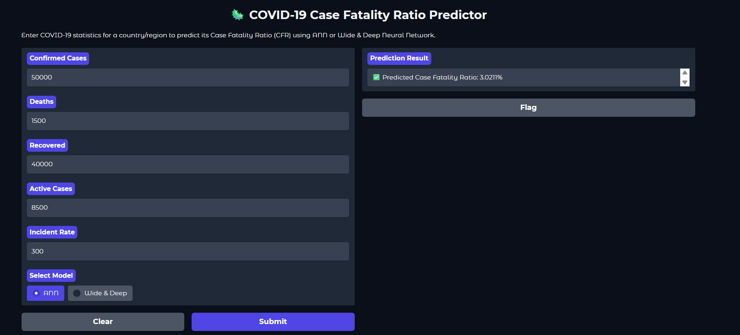
Fig 17: Gradio Prediction Interface
The inputs are the number of cases of COVID-19, and the interface allows users to select a model, accept user-inputted values and display the fatality ratio in real-time using the web application [15].
CONCLUSION
This approach proves to be efficient for designing and evaluating two Deep Learning models to predict the Case Fatality Ratio related to the spread of COVID-19 disease. It should be noted that ANN and Wide & Deep models show comparable good regression results while working with such indicators as confirmed cases, deaths, recovery cases, active patients, and the infection rate. The obtained results show that the optimisation of data preprocessing, normalisation, and the training process leads to better prediction results. The comparison shows that the hybrid learning approach might prove more effective compared to traditional neural networks when analysing complex healthcare data. In addition to this, the development of a web application increases usability as users can make predictions in real time.
The comparative analysis revealed that the hybrid approach of the Wide & Deep model can yield better results than traditional neural network models in working with complex healthcare datasets. This is due to the fact that the model utilises a combination of linear memorisation and non-linear deep learning methods. As a result, the model is able to detect simple relationships between features as well as complicated hidden relationships, which is highly useful when processing real-life data. One of the most important outcomes of this research project has been the development of a web interface with Gradio that could accept real-time data on cases of infection with the coronavirus and produce Case Fatality Ratio predictions. In conclusion, this research confirmed that the deep learning approach enables obtaining highly accurate and scalable solutions for the problem of disease prediction and decision-making in healthcare. Further development of this area may include using big data sets and transformer models.
REFERENCES
[1] Arik, S., Li, C.L., Yoon, J., Sinha, R., Epshteyn, A., Le, L., Menon, V., Singh, S., Zhang, L., Nikoltchev, M. and Sonthalia, Y., 2020. Interpretable sequence learning for COVID-19 forecasting. Advances in Neural Information Processing Systems, 33, pp.18807-18818. https://proceedings.neurips.cc/paper/2020/hash/d9dbc51dc534921589adf460c85cd824-Abstract.html
[2] Rodriguez, A., Tabassum, A., Cui, J., Xie, J., Ho, J., Agarwal, P., Adhikari, B. and Prakash, B.A., 2021, May. DeepCOVID: An operational deep learning-driven framework for explainable real-time COVID-19 forecasting. In Proceedings of the AAA iConference on Artificial Intelligence (Vol. 35, No. 17, pp. 15393-15400). https://ojs.aaai.org/index.php/AAAI/article/view/17808
[3] J. H. University Centre for Systems Science and Engineering (CSSE), “COVID-19 Data Repository,” 2020. Available: https://github.com/CSSEGISandData/COVID-19
[4] Sharifani, K. and Amini, M., 2023. Machine learning and deep learning: A review of methods and applications. World Information Technology and Engineering Journal, 10(07), pp.3897-3904.
[5] Taye, M.M., 2023. Understanding of machine learning with deep learning: architectures, workflow, applications and future directions. Computers, 12(5), p.91.
[6] Li, H., Wang, Z., Yue, X., Wang, W., Tomiyama, H. and Meng, L., 2023. An architecture-level analysis on deep learning models for low-impact computations. Artificial Intelligence Review, 56(3), pp.1971-2010.
[7] Ahmed, S.F., Alam, M.S.B., Hassan, M., Rozbu, M.R., Ishtiak, T., Rafa, N., Mofijur, M., Shawkat Ali, A.B.M. and Gandomi, A.H., 2023. Deep learning modelling techniques: current progress, applications, advantages, and challenges. Artificial Intelligence Review, 56(11), pp.13521-13617.
[8] Upadhyay, A., Chandel, N.S., Singh, K.P., Chakraborty, S.K., Nandede, B.M., Kumar, M., Subeesh, A., Upendar, K., Salem, A. and Elbeltagi, A., 2025. Deep learning and computer vision in plant disease detection: a comprehensive review of techniques, models, and trends in precision agriculture. Artificial Intelligence Review, 58(3), p.92.
[9] Dentamaro, V., Impedovo, D., Musti, L., Pirlo, G. and Taurisano, P., 2024. Enhancing early Parkinson’s disease detection through multimodal deep learning and explainable AI: insights from the PPMI database. Scientific Reports, 14(1), p.20941.
[10] Sharma, S. and Guleria, K., 2023. A deep learning-based model for the detection of pneumonia from chest X-ray images using VGG-16 and neural networks. Procedia Computer Science, 218, pp.357-366.
[11] Teo, Z.L., Jin, L., Liu, N., Li, S., Miao, D., Zhang, X., Ng, W.Y., Tan, T.F., Lee, D.M., Chua, K.J. and Heng, J., 2024. Federated machine learning in healthcare: A systematic review on clinical applications and technical architecture. Cell Reports Medicine, 5(2).
[12] Shiri, F.M., Perumal, T., Mustapha, N. and Mohamed, R., 2023. A comprehensive overview and comparative analysis on deep learning models: CNN, RNN, LSTM, GRU. arXiv preprint arXiv:2305.17473.
[13] Rafique, R., Gantassi, R., Amin, R., Frnda, J., Mustapha, A. and Alshehri, A.H., 2023. Deepfake detection and classification using error-level analysis and deep learning. Scientific Reports, 13(1), p.7422.
[14] Mathivanan, S.K., Sonaimuthu, S., Murugesan, S., Rajadurai, H., Shivahare, B.D. and Shah, M.A., 2024. Employing deep learning and transfer learning for accurate brain tumour detection. Scientific Reports, 14(1), p.7232.
[15] Mathivanan, S.K., Sonaimuthu, S., Murugesan, S., Rajadurai, H., Shivahare, B.D. and Shah, M.A., 2024. Employing deep learning and transfer learning for accurate brain tumour detection. Scientific Reports, 14(1), p.7232.

Code: https://colab.research.google.com/drive/17HNO5iUOgt8CB47bvgI7fcIdYhgbLvGp?usp=sharing

YouTube: https://youtu.be/3PUri07g16k

